JobQuest Navigator – Week 7 Update Report

Maria Soto, Shruti Amit Vasanwala, Zhihuai Wang, Ishan Aakash Patel

Team 9
The Zombies of CAA

Seneca Polytechnic
Course Code: CAA900
David Chan

Project Summary

Weekly Meeting Minutes and Materials
Access the documents from our weekly meetings
00 Documents/0099 Final Documents/Reports/Meetings

Accomplishments

Completed Work

Challenges or Blockers

User Story | Task | Challenges or Blockers

Plan for Next Week
Sprint: Sprint 5
Sprint Dates:
15June 2025 to 22 June 2025
Epic | Owner | Task

Sprint Status and Timeline

- Progress Tracking:
  - Use Jira for task management and sprint tracking.
    - List - The Zombies of CAA - Jira
  - Update GitHub weekly for documentation and progress updates.
    - https://github.com/MariaVSoto/JobQuest_Navigator_CAA/tree/dev
- Next Steps:
  - Work on assigned tasks per the above plan.
  - Address blockers and share progress in weekly meetings.
  - Ensure all documentation and code are up-to-date in the project repository.

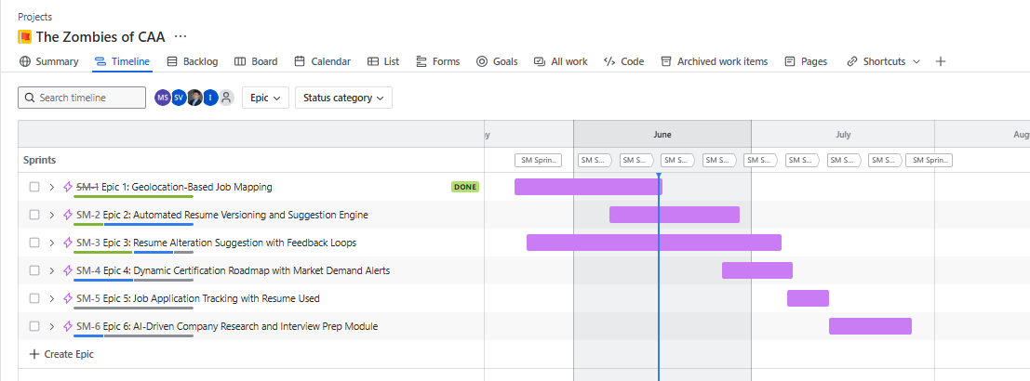
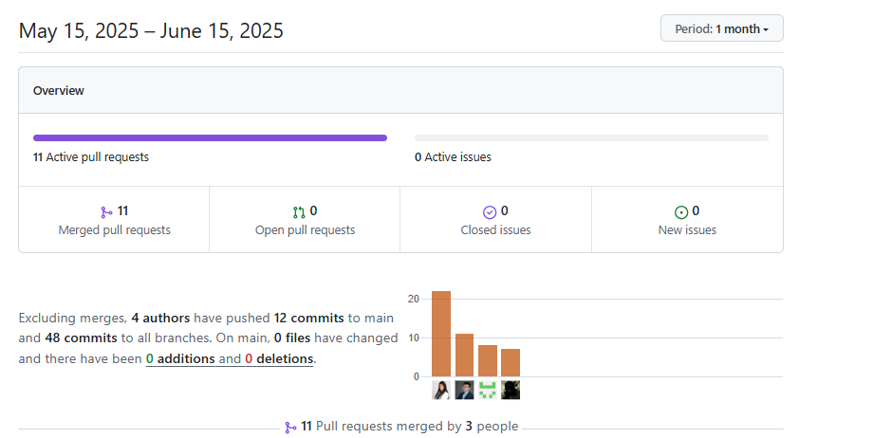

Tools to develop the project

Based on project requirements and your preferences, the following technology stack is selected:
- Frontend: React.js
- Backend: Django (Python, full-featured, powerful ORM, suitable for rapid development and robust microservices)
- Backend runtime: Lambda (serverless deployment for backend services; enables automatic scaling, pay-per-use billing, and simplified infrastructure management. Each microservice or API endpoint can be deployed as an independent Lambda function, integrated with API Gateway for HTTP access. This approach reduces operational overhead and is well-suited for event-driven or microservice architectures.)
- Database: MySQL (for all structured data, including users, jobs, applications, certifications, interviews, etc.)
- File/Object Storage: AWS S3 (for all resume files and version history, only metadata stored in MySQL)
- Map/Geo Service: Google Maps API (for geolocation display and geocoding)
- AI Service: OpenAI API (for AI-powered suggestions, interview preparation, etc.)
- Job Data API: Adzuna (the only job data aggregation source for now, extensible in the future)
- CI/CD: GitHub Actions (for automated testing, building, and deployment)
- CD Environment & Infrastructure: Provisioned and managed using Terraform
- API Debugging & Testing: Performed using Postman

